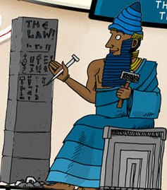
The famous Babylonian king Hammurabi, was the first ruler who had written code of laws. The laws of Hammurabi were written on a giant stone pillar, called stele. His rules were based on the ancient principle of ’eye for an eye’. Beside that, this code was the first appearance of ’presumption of innocence’, the protection of the weaker and the idea of ’common good’.

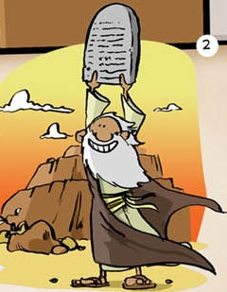
The Bible says that Moses wrote down Ten Commandments, the will of God on the Mount Sinai. Basic principles are: don’t kill, don’t steal, respect your family and don’t bear false witness. Siddhartha Gautama, founder of another great religion Buddhism taught respect of life, nonviolence and purity to his followers.

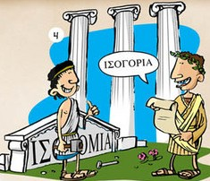
The political career of Pericles was linked with the golden age of democracy in Athens. The classical democracy is the rule of the people (demos), where everybody is equal before the law, freedom is the basic principle and always the majority decides.
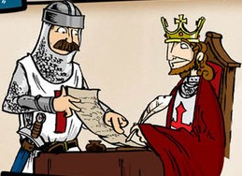
The nobles of England and the Hungarian Kingdom fought for their rights almost the same time. The 2 written documents (Magna Charta Libertatum, Bulla Aurea) had many commonalities, like the ban of imprisonment without legal judgment or the right of resistance if the king violates the law.

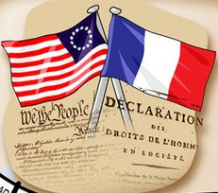
The American ’Declaration of Independence’ and the French ’Declaration of Human and Civil Rights’ were based on the thoughts of the masterminds of age of Enlightenment, like John Locke, Thomas Jefferson or Montesquieu. These documents declared the principles of freedom, fraternity and equality.

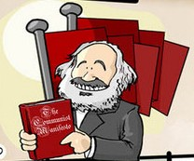
As the effect of Industrialization the working class evolved. Many new philosophies dealt with the rights and living conditions of labors: anarchists, Christian socialists, socialists. Karl Marx and Johannes Engels tried to unify these ideas at the Second International.

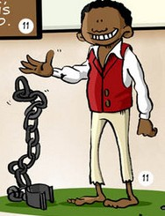
The first step to end slavery was the pact between England and France about the prohibition of slave trade. In the US president Lincoln freed the slaves during the civil war. By the end of 19th century several international agreements against slavery were signed.

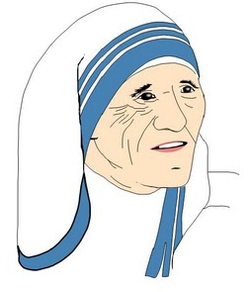
Mother Teresa established orphanages and schools for poor children in India. Ten years after she got the Nobel peace prize, the Assembly of the United Nations accepted the Convention on the Rights of the Child. This document bans child labor, arranged marriages and makes elementary education mandatory.

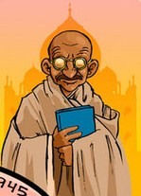
Mahatma (means High Soul) Gandhi is the father of nonviolent movements. He experienced oppression in South Africa and India too. He taught civil disobedience to people: not to pay taxes and to ignore British economic system. He was committed advocate of religious reconciliation. He never got Nobel peace prize because of political reasons.

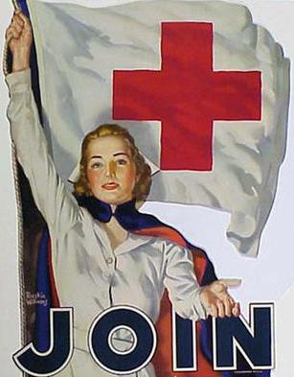
Due to technical development the wars became more and more destructive. This issue brought International Red Cross to life. The organization operates in peace and in war as well, their principles are impartiality, humanity, universality and volunteering. The Red Cross initiated the Geneva Conventions that protects the rights of prisoners of war, the wounded and civilians in wartime.

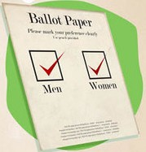
The word suffragette means the right to vote. The suffragette movement broke out in the UK where the authorities scorned the women activists with that name. The activists chained themselves in public, burned mailboxes, accepted imprisonment and made hunger strikes. New-Zealand was the first country which gave voting right to women.

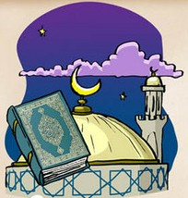
Prophet Muhammad wrote about what a faithful Muslim should do. The Quran says that a Muslim should donate to the poor, wishes the same for him/herself as to others and believes that an act should be judged by the purpose.
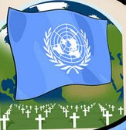
World War II ruined half of the world, especially Europe and South-East-Asia. World leaders created United Nations and Council of Europe due to this shock. These organizations aimed to solve conflicts peacefully, with international agreements. The UN General Assembly adopted the Universal Declaration of Human Rights on 10th of December 1948.

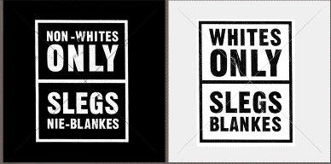
The status of black people was not been resolved with the ban of slavery. In South Africa the government enforced the apartheid system, which divided the society into 4 groups. Nelson Mandela and his companions fought for equal rights for almost 50 years. Meanwhile in the USA reverend Martin Luther King Jr. struggled nonviolently for the civil rights of African-American people.

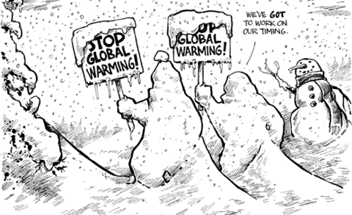
The ideas of global responsibility, environmentalism and sustainable development gain more and more attention worldwide. The Kyoto Protocol regulates the emission of greenhouse gases. Fair Trade is an operating alternative worldwide commercial network. Wangari Maathai got Nobel peace prize for combating desertification.
Possible solution:
- Hammurabi 18th century BC
- Moses 13th century BC
- Pericles 5th century BC
- Muhammad 7th century AD
- Magna Charta 13th century AD
- Declaration of Independence 1776, Declaration of Human and Civil Rights 1789
- British and French pact against slave trade 1807, Lincoln’s Emancipation Proclamation 1863
- Founding of Red Cross 1863 (Geneva Conventions 1864, 1906, 1929, 1949)
- Industrialization (Watt’s steam engine 1765), Second International 1889
- Suffragette movement in UK (beginning of 20th century), New-Zealand gives voting right to women 1893
- Gandhi’s struggle for the independence of India 1915-47
- Founding of United Nations 1945, Council of Europe 1949
- Apartheid system in South Africa 1948-1994, Martin Luther King’s March on Washington 1963
- Mother Teresa’s Nobel prize 1979, Convention on the Rights of the Child 1989
- Kyoto Protocol 1997

